**Quincy Art Association Fall 2025**

**Drawing Made Easy**

**Course description:**

Beginner students will become acquainted with line and mark-making of each tool and use this as the basis for moving on to the next concept in what it takes to create a “realistic” looking drawing of still life objects. Learn how to control “line-weight” by creating different types of lines and discover how “line” becomes “value” in developing a realistic drawing.

Learn to draw simple subjects working from life using their choice of*:* Pencil, graphite or charcoal while exploring the difference between various types of papers and what would be the best for individual use.

**(see supplemental pages for supplies list and retail art supply locations)**

**Drawing Made Easy**

**Supplies List**:

**Pencils/Pencil set** – any number 2 or any quality drawing pencil set from art supply

store

**Erasers** – Kneaded erasers

**Tortillons / “drawing stumps”**

**Drawing Paper/Pad –** newsprint or Strathmore drawing paper

See supplemental pages for retail purchasing options

**Retail Sales & Art Supply Stores:**

Dick Blick – (screenshot):

<https://www.dickblick.com/?gclid=CjwKCAjwyNSoBhA9EiwA5aYlb1iOXMXFbbSGZfPjmwvo9sXwJnDlDr57Dh2GLS_C1nC7TC7kmWzMihoCx9cQAvD_BwE>

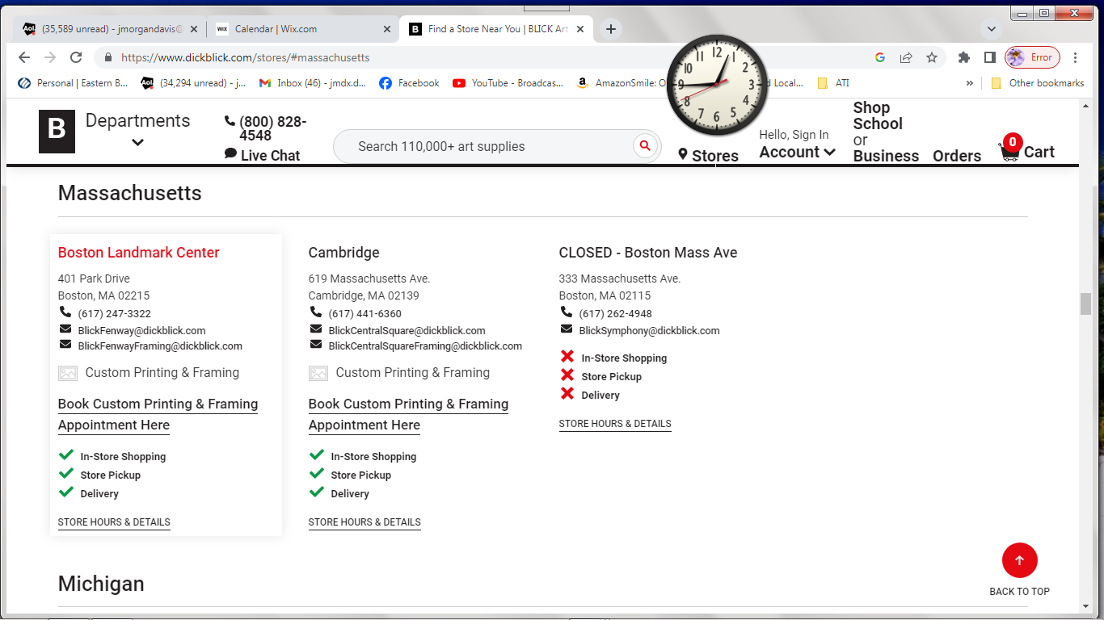

Jerry’s Artorama:

Providence, RI (directions not available in this supply list) but this is the link to their online

<https://www.jerrysartarama.com/?gad=1&gclid=CjwKCAjwyNSoBhA9EiwA5aYlby5DbSitx63e7eORPEsqB1fPASJ8TUjd-OSScOqnutu_PalJcWQA0BoCqjcQAvD_BwE>

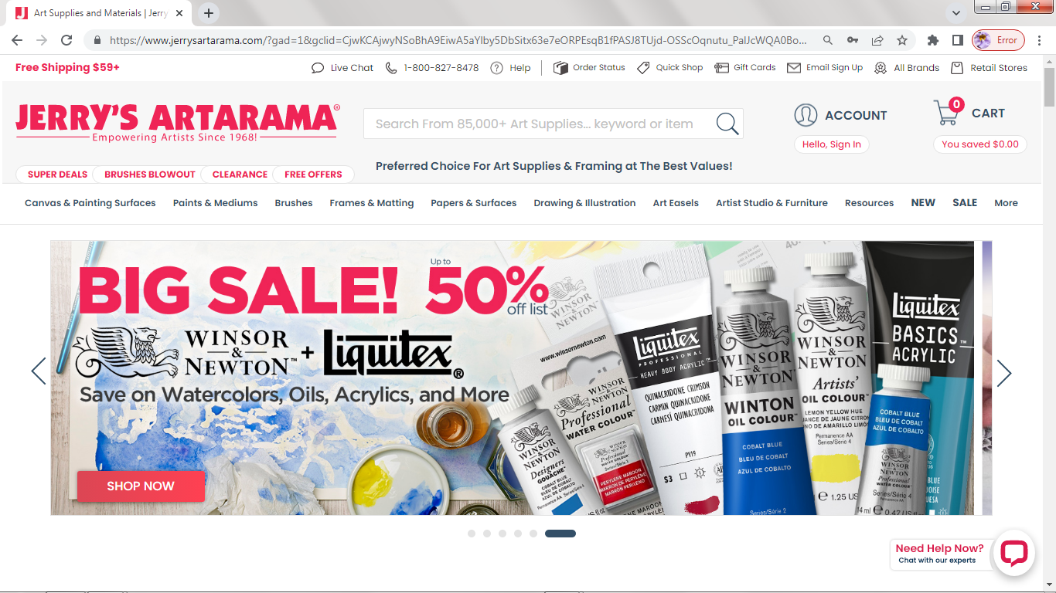

Cheap Joe’s

<https://www.cheapjoes.com/>

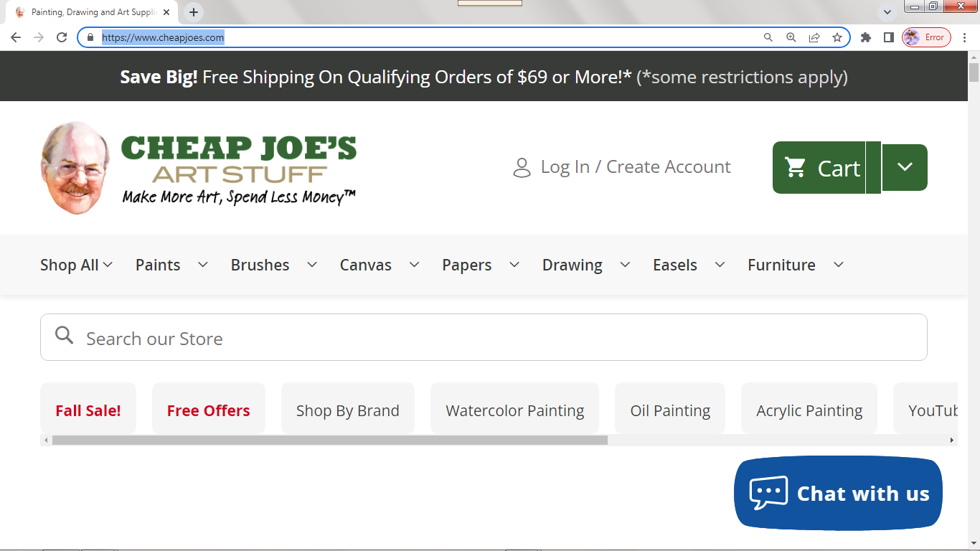

Utrecht:

<https://www.utrechtart.com/?9gtype=search&9gkw=art%20supplies&9gad=14147767268.1&9gpla=&9gag=4525063388&gclid=COT9ubSLhLACFQrf4Aodq2RWkg>

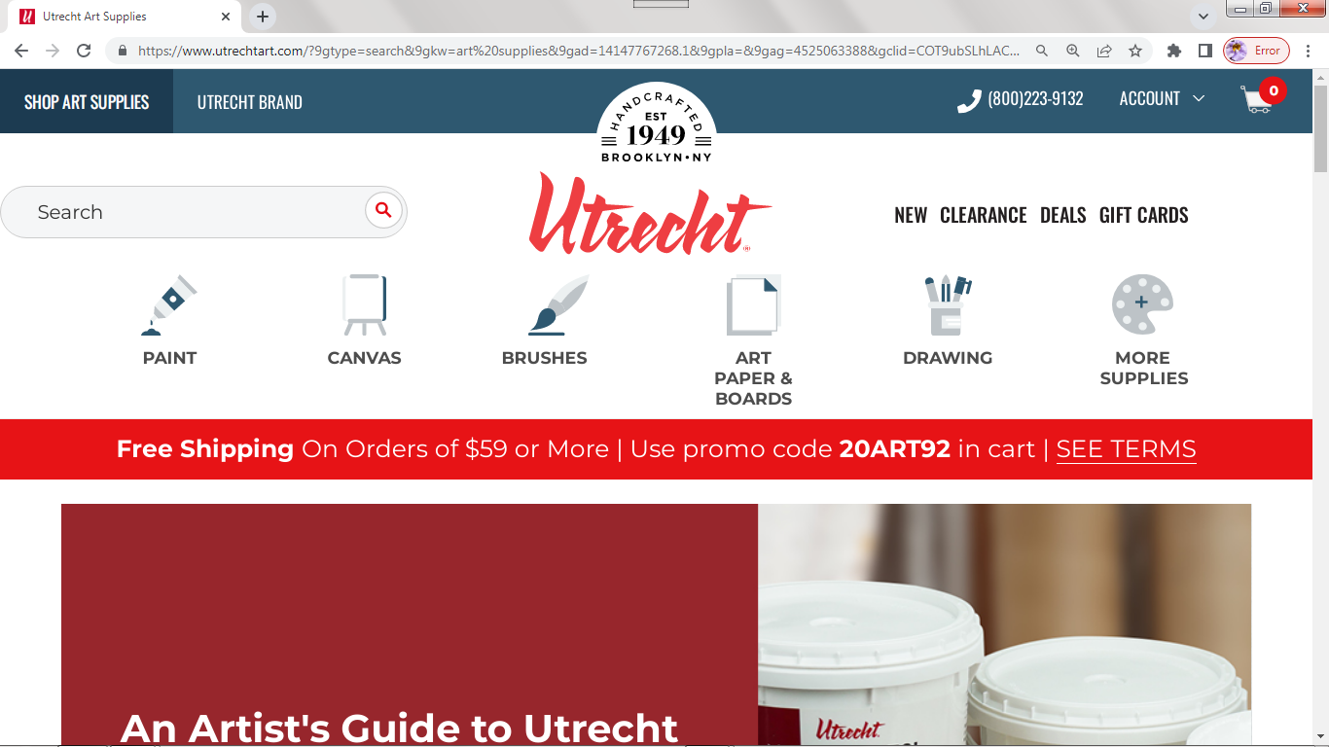

Hobby Lobby – Braintree

Contact Info:

Cell Phone: 617-833-8092 email: [jmorgandavis@aol.com](mailto:jmorgandavis@aol.com)

link to website: <https://www.jmdfineart.com/>

link to facebook page: <https://www.facebook.com/jmdfineart>

link to YouTube Channel: <https://www.youtube.com/channel/UCRn08uG6HCiePmVtkDeFgQA>