QAA – Oil Painting Class Fall 2023

Class Title: Basic Painting
Adults

Course Description:

Working from life, still life or image references students will develop and apply their skills of observational awareness by creating original works of art reflecting the basics of line, color and design.

Through the oil painting medium, students will focus on completing the painting by composing simple yet strong dynamic designs by describing light on form through value and color. Students will discover the potential of the oil painting medium and learn how to harness it to create life- like, three dimensional scenes on the two dimensional surface

Materials List:

Paints: Grumbacher OR Windsor & Newton are quality oil paints
a warm and a cool of each of the primaries:
yellow, red, blue

titanium white,
cadmium yellow pale/ or lemon yellow
cadmium yellow medium
cadmium vermillion/ or cad red light
alizarin crimson
thalo rose (optional)
cerulean blue (or cerulean blue hue – more affordable)
ultramarine blue

Brushes: natural bristle brushes, flats; variety of sizes, 2,4,6, 8 10 12

Brush Holder:
any type of cup that will either clip on to the easel or sit securely on the table

Palettes: either wooden, plexiglass or disposable palette with airtight container for preservation

Supports: either canvas, canvas panel; canvas papers

Solutions: turps (Gamsol seems to be the most acceptable)

Solution cup: either tin or glass; small tin can or baby food jar with lid etc…

Extras: paper towels, brush holders, solution cups, mirrors etc…

(continued on next page):

Retail Sales & Art Supply Stores:

Dick Blick – (screenshot):
https://www.dickblick.com/?gclid=CjwKCAjwyNSoBhA9EiwA5aYlb1iOXMXFbbSGZfPjmwvo9sXwJnDlDr57Dh2GLS_C1nC7TC7kmWzMihoCx9cQAvD_BwE
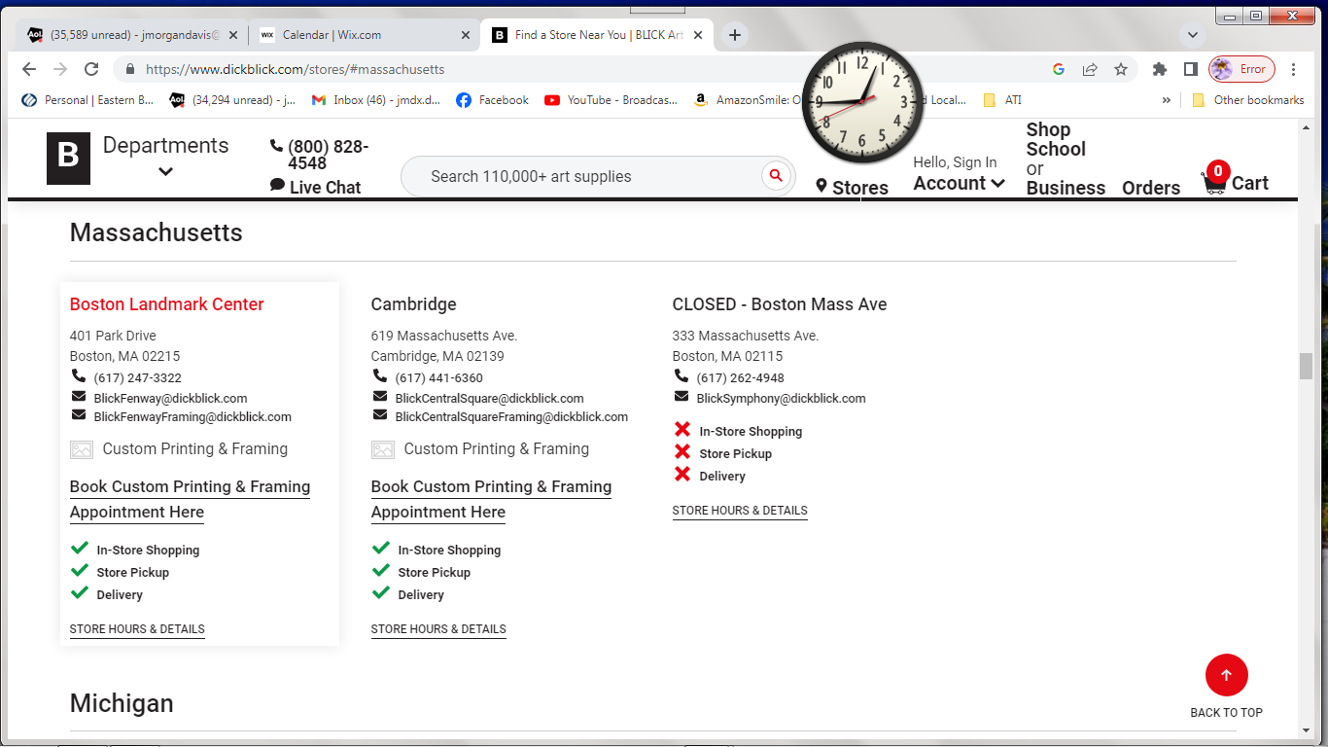

Jerry’s Artorama:
https://www.jerrysartarama.com/?gad=1&gclid=CjwKCAjwyNSoBhA9EiwA5aYlby5DbSitx63e7eORPEsqB1fPASJ8TUjd-OSScOqnutu_PalJcWQA0BoCqjcQAvD_BwE
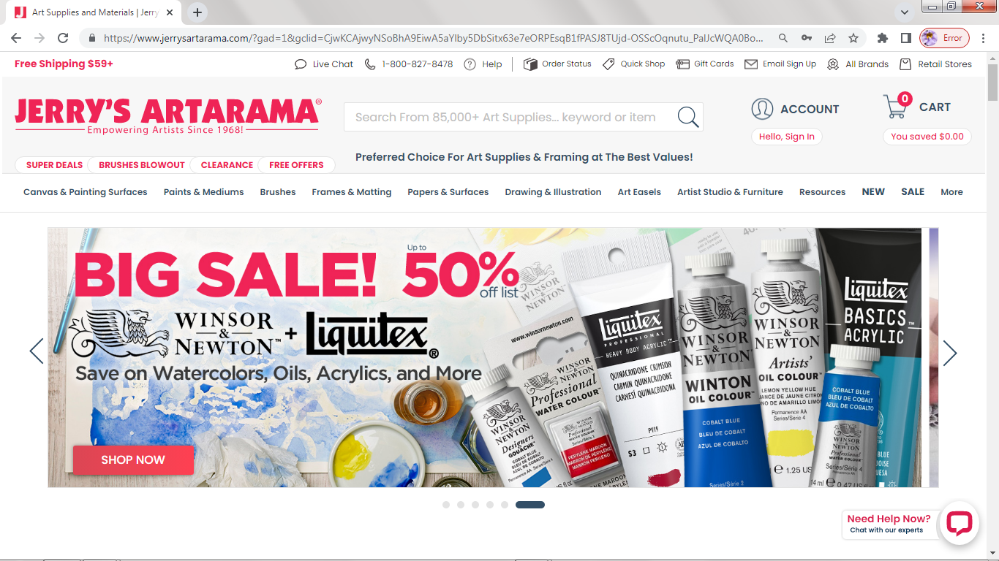
Cheap Joe’s
https://www.cheapjoes.com/

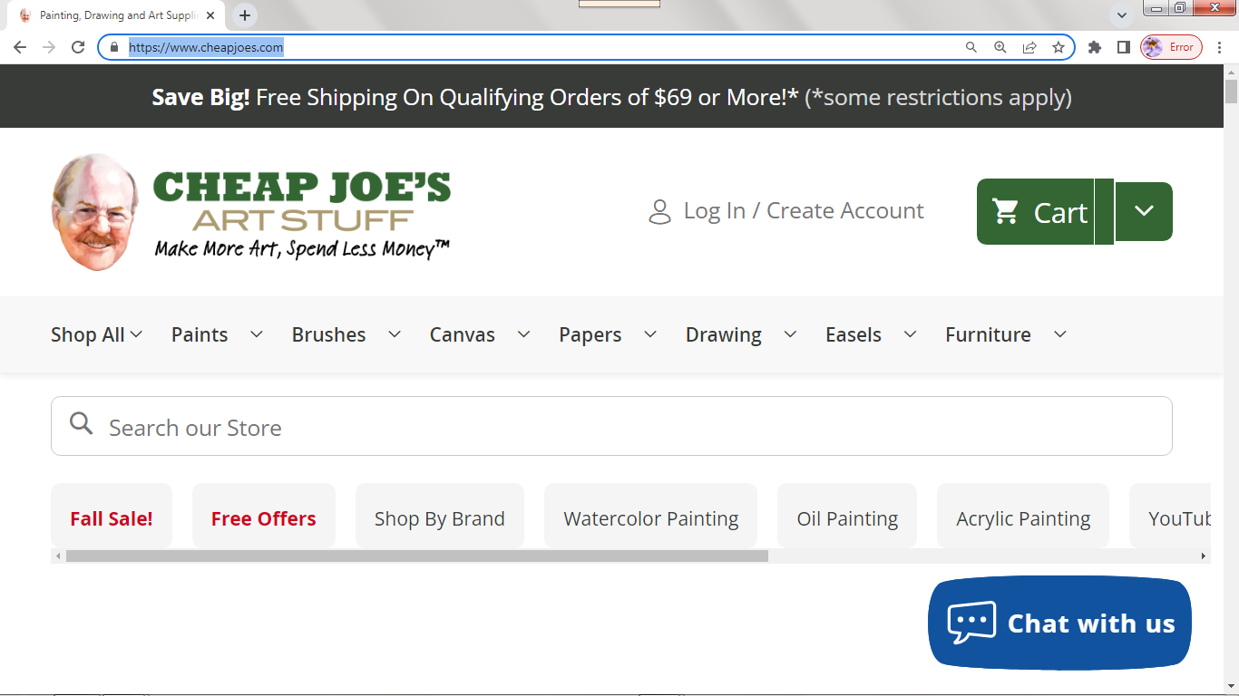

Utrecht:
https://www.utrechtart.com/?9gtype=search&9gkw=art%20supplies&9gad=14147767268.1&9gpla=&9gag=4525063388&gclid=COT9ubSLhLACFQrf4Aodq2RWkg

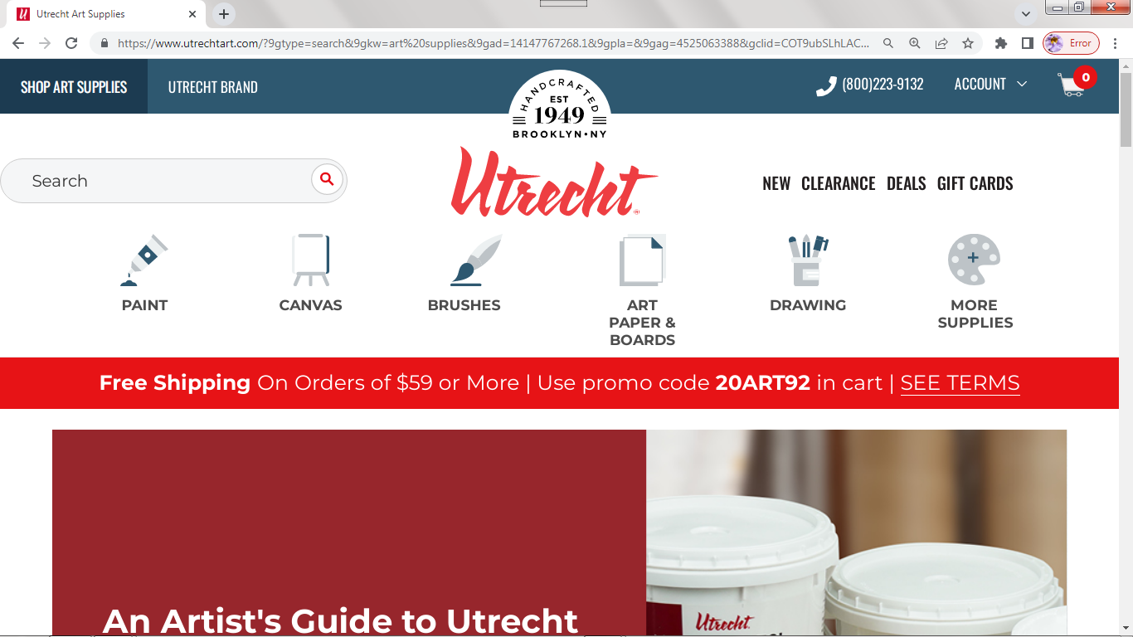

Contact Info:
Cell Phone: 617-833-8092 email: jmorgandavis@aol.com
link to website: https://www.jmdfineart.com/
link to facebook page: https://www.facebook.com/jmdfineart
link to YouTube Channel: https://www.youtube.com/channel/UCRn08uG6HCiePmVtkDeFgQA
Student Contact Info:

Hi,
Great news! Someone just booked one of your services.
Here are the details:
Customer Info
Name: Fran McGillicuddy
Email: fmcgillicuddy@comcast.net
Phone Number: 6173289669
Number of Participants: 1
Email: fmcgillicuddy@comcast.net

Hi,
Great news! Someone just booked one of your services.
Here are the details:
Customer Info
Name: Lauren TeBeau
Email: tebeau12@gmail.com
Phone Number: 5859919356
Number of Participants: 1
Email: tebeau12@gmail.com

Hi,
Great news! Someone just booked one of your services.
Here are the details:
Customer Info
Name: Mark Coughlan
Email: markdraw@comcast.net
Phone Number: 7819290211
Number of Participants: 1
Email: markdraw@comcast.net

